**ABOUT US**

Tropitech Kenya Limited is a dedicated provider of agricultural services, consulting and innovations, Environmental sustainability services and Health and safety services. Our company was founded with the goal of making a positive impact on the world by promoting sustainable agricultural practices while also helping other sectors maintain the highest standards of health and safety compliance, environmental responsibility, and food safety. We cover all food chains in agricultural sector, and also provide services in capacity building and compliance.

We work closely with our clients to develop customized solutions that meet their unique needs and help them achieve their goals. We also believe in building strong relationships with our clients and working closely with them to achieve their goals. Our commitment to excellence and innovation is what sets us apart, and we are always striving to stay at the forefront of the latest trends and technologies in the industry.

**Mission**

To become a regional goods and service provider company of choice with quality as the main driver. We endeavor to build a win relationship with our clients.

**Vision**

To partner with organizations, businesses and farmers to realize their full potential.

**CORE VALUES- TROP**itech

**T**rust-Our trust is earned through deeds

**R**eliability- We are dependable to deliver as promised

**O**rganization-We are methodical and efficient in every operations we undertake

**P**roficiency-We have the knowledge, Skill and aptitude to deliver

**OUR TEAM**

**Tropitech** is a diverse, team-orientated company with a strong emphasis on implementing innovative solutions for our clients. The team comprises of the following experts;

* Agriculture and crop protection specialists
* Environmentalists
* Horticulturalists
* Health and safety practitioners
* Engineers
* Landscapers and Urban Planners
* Food analysts
* Chemical Analysts
* Research consultants

The team has undertaken work in East Africa and across the Sub - Saharan region, and hence have detailed knowledge of and expertise in these fields at a local and regional level.

**SERVICES;**

AGRICULTURAL INPUT SUPPLY

We recognize the uses of environmental sensitive innovations that are affordable to growers under their conditions. Our focus is on seeds supply, supply of healthy seedlings, fertilizers and pesticide supply.

In partnership with other organizations and suppliers, Tropitech aims to provide advanced and modern production systems and technologies which will optimize productivity and improve quality of farm produce. Our team of experts is always on the lookout for new and innovative products that can help our customers achieve better results and improve their bottom line.

AGRICULTURAL CONSULTANCY

Tropitech endeavors to provide farm based consultancy that improve the horticultural production and enabling farmers produce sustainably. We offer a wide range of consulting services, including crop management, soil testing, environmental impact assessment, market analysis, regulatory compliance, and more. We have a team of agronomists and other experienced experts who are always available to provide customized professional solutions and support to farmers and agribusiness to maximize productivity and meet their unique needs.

We also provide support in capacity building to farmers and agribusinesses to ensure success of their farming enterprises.

LANDSCAPE DESIGN AND MANAGEMENT

Tropitech provides expert advice, guidance, and support to clients in the planning, design, construction, and maintenance of outdoor spaces. We have a team of experienced landscape professionals who have a deep understanding of plants, hardscape materials, design principles, and local environmental regulations. Our aim is to design landscapes and manage landscape plants that provide cultural, ecological, and production functions.

Our consultancy services include the following;

* **Site analysis**- This involves evaluating the existing conditions of the site, including the topography, soil conditions, drainage, and existing vegetation. It aids in design concept that takes into account the client's goals, budget, and environmental constraints.
* **Concept and design development**- We create detailed plans, including hardscape features such as walkways, patios, walls, and water features, as well as plant selection and placement. We also provide recommendations for lighting, irrigation, and other site amenities.
* **Project management** –We oversee the construction process, coordinating with contractors and vendors, and ensuring that the project is completed on time and within budget.
* **Ongoing maintenance and management support**- Our team of experts will provide regular site visits, plant care and maintenance, pest management, and seasonal adjustments to irrigation and other systems to achieve the client needs.

FOOD SAFETY AND QUALITY ASSURANCE

Tropitech endeavors to provide exemplary food safety and Sanitation programs in line with the existing government and customer compliance standards. We aim to assist Food production companies, food chemical supply companies and government inspection agencies in East Africa to abide by the regulatory authorities compliance and ensure production for the market that meet the required threshold.

We also provide training, support and supervise a team of quality assurance technicians to implement policies, strategies, and methodology testing.

CHEMICAL ANALYSIS SERVICES

Chemical analysis services plays a critical role in ensuring the safety, quality, and performance of products in a variety of industries. Tropitech has experts with extensive knowledge and expertise in the field of chemical analysis. The team is well equipped to provide guidance on regulatory compliance, quality control, and assurance, and may assist with the design and implementation of analytical projects.

We deal with a wide range of industries, including pharmaceuticals, food and beverage, environmental testing, and materials science. By leveraging the expertise of our experienced experts, companies can gain a competitive edge and enhance the quality and safety of their products and services.

MONITORING AND EVALUATION SERVICES

In the current Fast paced World, Tropitech understands Organizations need to know what is working and what is not working and to make informed decisions on how to improve their programs and projects. We also understand that a typical project in reality consists of many moving parts that must work together to meet deadlines and if one part breaks down it can cause delays and financial losses.

We have a team of experts that will provide a system in place to monitor and evaluate a projects progress. The team also aims to help organizations to assess the impact and effectiveness of their programs and projects, identify areas for improvement, and develop evidence-based strategies to achieve better results.

ENVIRONMENTAL SUSTAINABILITY CONSULTANCY

Tropitech aims to help organizations comply with environmental regulations and improve their environmental performance. We focus on helping organizations achieve their sustainable goals, address stakeholder concerns and social risks and implement what is in line with the environment. Our other goal is to help in reducing environmental impact and promote sustainable practices, while also improving the clients bottom line through cost savings and increased efficiency. Our area of expertise ranges mainly in the following areas;

* Environmental and Social Impact Assessments(ESIA)
* Environmental Audits
* Stakeholder Mapping and Community Engagement
* Rural Participatory Approaches
* Waste reduction and management strategies
* Carbon Foot printing
* Capacity development and community need assessments
* Data Collection and Baseline studies
* Compliance

OCCUPATIONAL SAFETY AND HEALTH SERVICES

Tropitech undertakes Occupational, health and Safety services as a boost to implementation of an effective health and Safety system in accordance with client specific needs. We also provide comprehensive OHS management systems with proper documentation, inspections and monitoring, trainings and action plans.

At Tropitech, we customize your OHS services and training needs and develop training modules that meet requirements of our clients’ requirements, local OHS requirements as well as International requirements. Our main focus involves the following areas of expertise;

* Internal and external audits-Fire safety audits and OSH audits
* Site Inspections and reporting
* Health and Safety documentations-SHE plans, safety standards and procedures
* Hazard Identification and risk assessments
* Provision of trained Onsite safety officers
* ISO 45001 Compliance audits
* Trainings and expert management

**CLIENTS**

  




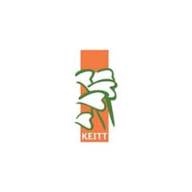



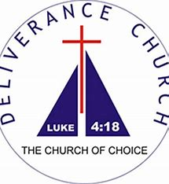

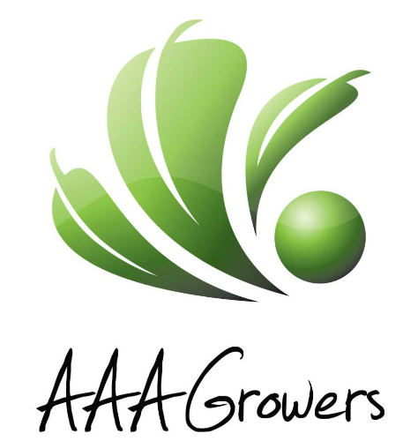

**CONTACT INFORMATION**

**8th Floor, Pinetree Plaza, Ngong Road**

**0726381347/0721738650**

**24834-00100, Nairobi, Kenya.**